Week 3 Registration Analysis
Project Title: Campus Cultural Fest Operations Dashboard & Process Optimization System
Prepared By: Karthick Raja
Objective
The objective of this analysis is to evaluate participant registration trends across cultural fest events and identify the most and least popular events.
Registration Data Analysis
SQL Query Used,
SELECT
Event_ID,
COUNT(*) AS Registrations
FROM Registrations
GROUP BY Event_ID
ORDER BY Registrations DESC;

Query Result
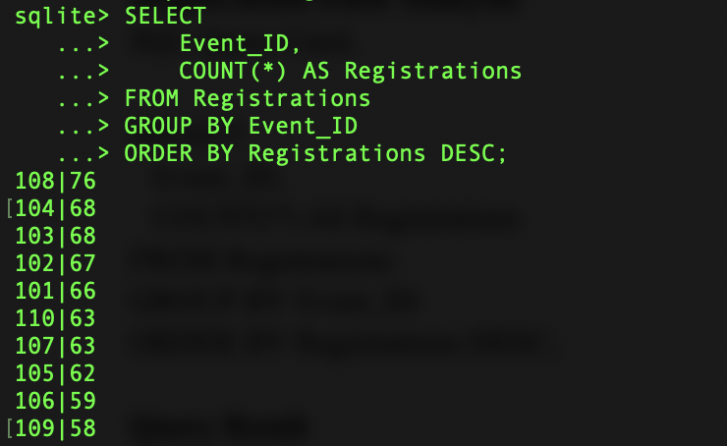Event 108 has 76 registrations.
Registration Summary
Event ID | Registrations
108 | 76
104 | 68
103 | 68
102 | 67
101 | 66
110 | 63
107 | 63
105 | 62
106 | 59
109 | 58
Key Findings
Finding 1: Highest Registered Event
Event ID 108 recorded the highest number of registrations with 76 participants.
This indicates strong participant interest in this event compared to others.
Finding 2: Lowest Registered Event
Event ID 109 recorded the lowest number of registrations with 58 participants.
Although it had the lowest registration count, participation was still reasonably distributed and no event experienced extremely low interest.
Finding 3: Balanced Registration Distribution
Registration counts ranged between: 58 to 76 participants
This suggests that registrations were fairly balanced across all events.
No single event dominated overall participation.
Finding 4: Strong Overall Participation
The total number of registrations generated for the cultural fest was 650 participants
This exceeds the project target of 600 participants and indicates strong engagement from students.
Visualization
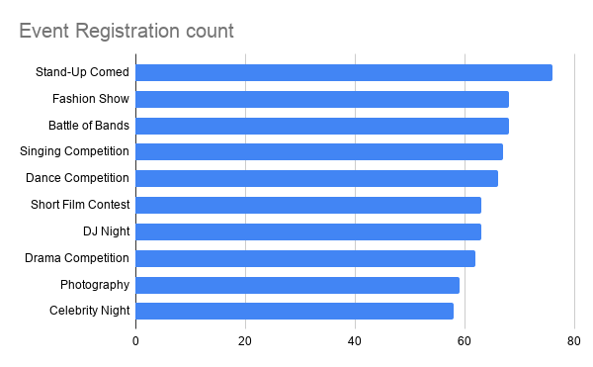
Where,
X-Axis → Event name

Y-Axis → Registration Count
Business Impact
The registration analysis provides useful information for event coordinators when planning future cultural festivals.
Understanding participant preferences can help:
- Allocate volunteers more effectively
- Arrange venue capacity
- Improve scheduling decisions
- Focus promotional activities on low-interest events
Recommendations
Based on the registration analysis:
Recommendation 1
Allocate additional volunteers to highly registered events such as Event 108.
Recommendation 2
Investigate why Event 109 attracted fewer registrations compared to other events.
Recommendation 3
Use registration trends to estimate attendance and resource requirements for future events.
Conclusion
The registration analysis showed healthy participation across all ten cultural fest events. Event 108 attracted the highest number of participants, while Event 109 received the lowest registrations. Overall registration distribution remained balanced, indicating successful event promotion and participant engagement.

